Name(s)___________Ameer Uzman____________________________________ Period ___B2___ Date ____2/15/2026_______________
 | Project Guide - Tell a Data Story | 

Background
Computing tools allow people from all different fields to learn from data. By transforming and visualizing data, we can find patterns that help us learn about our world.

For this project, you will

- Select a dataset from the Data Library
- Use the Data Visualizer to make a visualization that helps us learn something interesting about the data
- Write a response that explains:
  - what your visualizations show
  - new insights or decisions that can be made based on this visualization
  - possible problems with your analysis,including potential bias in the data or your interpretation

Tell a Data Story

Data Analysis Process | Written Response
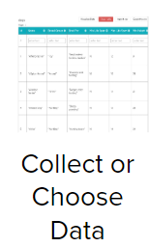 | Select a dataset from the Data Library. Read the metadata to understand what information is available in the table  Dataset Name:  I am using the world democracy dataset  Short Description:  The dataset contains information and ratings of their governments
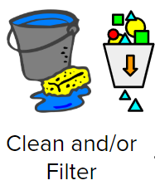 | Did you filter or clean the data? Why or why not?  I filtered data by the functioning of their government. I wanted to only consider the governments that were looking before I compared political participation and civil liberties.
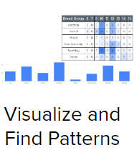 | Create a visualization. Copy/paste the chart below.
 | What information does your visualization show:  I noticed that the more political participation a country has, The more the citizens enjoy Civil liberties.  What new insights or decisions can be made based on this visualization:  If people want more freedom or civil liberties, they should be more involved and participate more in their government  What are the possible problems with your analysis including potential bias in the dataset or your interpretation:  A potential bias is that I live in a country with a good amount of civil liberty and political participation.

Rubric

Category | Extensive Evidence | Convincing Evidence | Limited Evidence | No Evidence
Collect or Choose Data | Dataset is correctly identified and description is complete. | Dataset is correctly identified and description is mostly complete. | Dataset is correctly identified and description is somewhat complete. | Dataset is not identified or description is missing.
Clean/Filter Data | Explanation for cleaning and/or filtering is complete and reasonable. | Explanation for cleaning and/or filtering is complete and mostly reasonable. | Explanation for cleaning and/or filtering is somewhat complete or somewhat reasonable. | Explanation for cleaning and/or filtering is incomplete.
Visualize and Find Patterns | Visualization is readable and includes a title, and citation. | Visualization is mostly readable and includes a title, and citation. | Visualization is somewhat readable and/or is missing a title or citation. . | Visualization is unreadable or missing.
New Information: Interpreting the visualization | The visualization is thoroughly explained. | The visualization is mostly explained. | The visualization is somewhat explained. | The visualization is not explained.
New Information:  Insights or Decisions | Insights or decisions are reasonable and effectively linked to information displayed in the visualization | Insights or decisions are mostly reasonable and effectively linked to information displayed in the visualization | Insights or decisions are mostly reasonable and somewhat effectively linked to information displayed in the visualization | Insights or decisions are missing.
New Information:  Bias | Possible problems with analysis or potential bias are reasonable and thoughtfully addressed. | Possible problems with analysis or potential bias are mostly reasonable and thoughtfully addressed. | Possible problems with analysis or potential bias are somewhat reasonable and addressed. | Possible problems with analysis or potential bias are not addressed.

